Who Builds BIG?
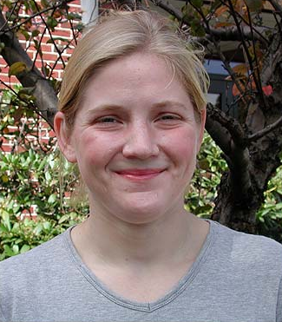
Susan Knack, Civil Engineer

Susan Knack is a civil engineer who specializes in building envelope issues. Since 1998, she has worked for Simpson Gumpertz & Heger, an engineering firm with offices in Arlington, Massachusetts, and San Francisco, California, that designs, investigates, and retrofits buildings and structures of all types.

Check out a structure that Susan worked on: New York State Capitol Building, Albany, New York

Have you always wanted to be a civil engineer?
My father was a carpenter, and my uncle was a civil engineer. They used problem-solving skills to design and build things, and I enjoyed helping them determine how things went together. I thought I had the skills necessary to solve engineering problems, and so it seemed like a good fit. It was really my desire to build things that led me towards a career in civil engineering.

Did you major in civil engineering in college?
I actually initially majored in computer science at Cornell University -- but only for one year. I changed my major because I did not feel connected to the projects I was working on, and wanted a job that got me out of the office more often. I felt solving engineering problems would have an impact in the real world, and liked how civil engineers could design things and then help to build something concrete. So my sophomore year in college, I switched my major to civil engineering. I'm glad I did.

So what kind of things do you do as a civil engineer?
Today I work for a company called Simpson Gumpertz & Heger, Inc. in Arlington, Massachusetts. My main job is dealing with building envelope issues. This means I investigate why buildings leak and deteriorate and design new construction and repairs to deal with these problems. Really, there's a varied mix of things I do. Sometimes I examine the condition of entire buildings, ranging from old historic buildings to modern office buildings, and other times I look at smaller issues -- like whether or not a window is properly attached and flashed. I do some of this work using industrial rope access, or rappelling, to see the building.

What is rappelling, and how did you get involved in it?
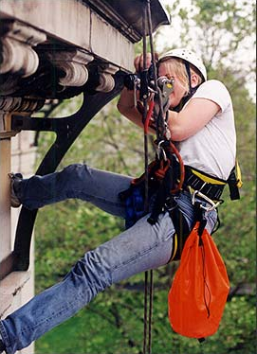
Rappelling, or what we call industrial rope access, is something my company has been involved in for several years. Basically, we harness ourselves to two ropes, scale down the side of a building, and examine its construction for various problems or conditions. The ropes give us access to spots on a building that conventional means just can't get to. For example, it's pretty hard to examine the inside of a big smokestack -- but rappelling makes it much easier.

Civil engineering is a field dominated by men. Have you ever felt intimidated being a female in a male-dominated field?
I've never had a problem being a female engineer. People generally respect quality work, no matter who produced it. And as more and more women enter the field, which was historically male-dominated, I do not think people will even view this as an issue.

So what are you working on right now?
Right now, I'm working on designing roof repairs for the New York State Capitol Building. The building is experiencing some stubborn leaks that we hope to solve. The roof is very steep and intricately designed, so rappelling is a handy way to examine its construction. I've had to do a lot of research on the Capitol Building because of its unique construction and the historical significance of the building.

What would you describe as the most fun thing about your job?
Applying problem-solving skills to solve real-life problems, visiting job sites, seeing my designs transformed from paper to real life, and every once in a while, getting to rappel off a building.

What advice do you have for kids who may want to pursue a career in civil engineering?
Take lots of math and science courses. Be aware of your surroundings -- look at buildings and structures, and try to figure out how they work. Think creatively about problem solving.

What was your favorite class in high school?
I've always loved problem solving, so my favorite classes in high school were math and computer science.

What was your least favorite class in high school?
I was never a real fan of English -- only because English is so subjective. There is no right or wrong in English. I had a hard time with that.

What was the most unique building that you've ever worked on?
It's a tie between the historic Quincy Market dome in downtown Boston, Massachusetts, and the New York State Capitol Building in Albany, New York.

What is the most frightening moment you've had as a civil engineer?
The most frightening moment of my career was the second I first stepped over the edge of a building to go rappelling! But even today, I get a little nervous when the wind whips around a building and the rope I'm on starts swinging back and forth!

What do you like to do in your free time?
I really enjoy the outdoors and activities like rock climbing and hiking. I even once went bungee jumping. I also enjoy woodworking and carpentry. Right now, I'm helping to restore a barn up in rural New Hampshire with a friend.

For more BIG builders, check out this website: http://www.pbs.org/wgbh/buildingbig/index.html

